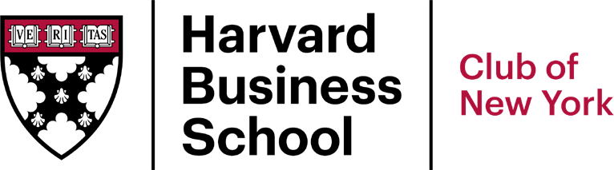
1460 Broadway, WeWork Bldg
New York, NY 10036 Tel: (929) 596-3820
www.hbscny.org

HARVARD BUSINESS SCHOOL CLUB OF NEW YORK

EVENT CODE OF CONDUCT AND RELEASE

My choice to participate in the Event is knowing, voluntary, and made for personal enrichment. In consideration of being permitted to attend the Event, I hereby agree to all the terms of this Event Code of Conduct and Release (the “Agreement”). Furthermore, I agree to abide by all Club policies including the abbreviated Code of Conduct and Values as set forth in this Agreement.

- CODE OF CONDUCT. Attendees of the Event are expected to:

- Cooperate with and respect the opinions of fellow attendees of the Event (including those speaking, moderating and otherwise working at the Event), and supporting actions of the Club and its leadership, even when the Attendee does not personally support the action taken.
- Act in a positive and supportive manner at all times during the Event.
- Show respect and courteous conduct to all in attendance and involved with the Event.
- Understand and respect that the Club is not a political organization and does not take political positions.

- VALUES.

- Respect for the rights, differences, and dignity of others
- Honesty and integrity in dealing with all members of the community
- Accountability for personal behavior

- FAILURE TO COMPLY. I understand and agree that if I do not comply with the Code of Conduct and Values as set forth in this Agreement or other Club Policies, I may be asked by a representative of the Club to leave the Event. I agree to promptly and willingly comply with such direction. Further, if I am asked to leave this Event, I understand and agree that I will not be able to attend future events organized, hosted, or sponsored in any way by the Club.

- LIABILITY RELEASE. I hereby release, discharge, indemnify and hold harmless the Club; and each of its present, former, or future volunteers, employees, shareholders, officers, representatives, and agents (the “Club Parties”; each a “Club Party”); from and against any claims, damages, lawsuits, expense, reasonable attorneys’ fees, and costs of litigation and/or settlement, as well as any liability due to any injuries, damages or losses to any person (including death) relating to or in connection with participation in the Event.

- INDEMNITY. I will defend, indemnify, hold harmless, and reimburse the Club and Club Parties from and for all damages, losses, costs, or expenses (including reasonable legal fees) incurred by the Club or Club Parties or paid by them to any person (including me or my insurers) in respect of any accident, injury (including death), loss, or property damage, however caused or resulting from, arising out of, or otherwise in connection with my attendance at the Event. I will reimburse the Club if anyone makes a claim against the Club in connection with my participation in the Event, including, without limitation, any accident I may be involved in or any injury, loss, damage to me, other parties or property however caused.

- COVENANT NOT TO SUE. I will not initiate any claim, lawsuit, court action, or other legal proceeding or demand against the Club or any Club Party, nor join or assist in the prosecution of any claim for money or other damages which anyone may have, on account of injuries (including death), losses, or damages sustained by me, other parties, or my (or others') property in connection with my attendance of the Event, and I waive any right I may have to do so. This means that I cannot sue to hold the Club or any Club Party responsible for any injury, loss, or damage sustained by me, other parties, or my (or others') property in connection with the Event, even if it is due to the ordinary negligence, injudicious act, omission, or other fault of the Club.

- ENTIRE AGREEMENT. I further represent and declare that this Agreement contains the entire agreement between the Club and the Attendee in relation to any claims that may arise from attendance at the Event; and that the terms of this Agreement are contractual and are not a mere recital. I agree that if any portion of this Agreement is held invalid or unenforceable by a court of competent jurisdiction, the remainder of this Agreement will continue in full legal force and effect.

I hereby declare that the terms of this Agreement have been completely read and are fully understood for the express purpose of precluding forever any claims against the Club or any Club Party for any purpose at any time arising out of or as a result of the Event.

________________________________
Signature of Attendee Address

________________________________
Print Name

Date

